**Asitha Mohan Paladan Chirakkal-DA 165-Assignment 3**

**1)      Update the categoryName From “Beverages” to "Drinks" in the categories table.**

**UPDATE categories**

**SET category_name='Drinks'**

**WHERE category_name='Beverages'**

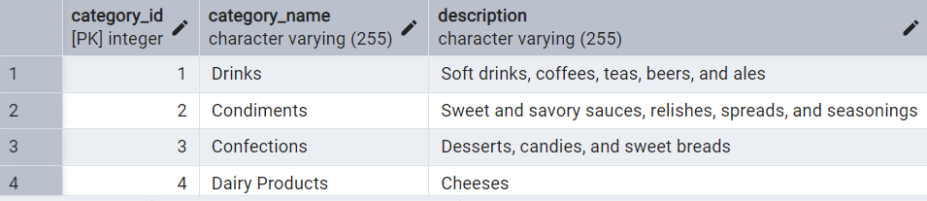

**2)      Insert into shipper new record (give any values) Delete that new record from shippers table.**

**INSERT INTO shippers(shipper_id,company_name)**

**VALUES (4,'Standard Shipping')**

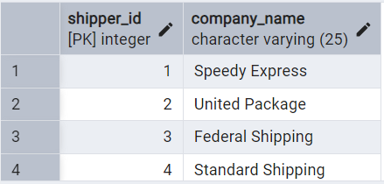

**DELETE FROM shippers**

**WHERE shipper_id=4**

**3)      Update categoryID=1 to categoryID=1001. Make sure related products update their categoryID too. Display the both category and products table to show the cascade.**

**Delete the categoryID= “3”  from categories. Verify that the corresponding records are deleted automatically from products.**

**In this case 1st we need to drop the constraint foreign key from child table**

**ALTER table products**

**DROP CONSTRAINT IF EXISTS fk_category**

**Then add the constraint :-**

**ALTER TABLE products**

**ADD CONSTRAINT fk_category**

**FOREIGN KEY(category_id)**

**REFERENCES categories(category_id)**

**ON UPDATE CASCADE**

**ON DELETE CASCADE;**

**Now we can do the update**

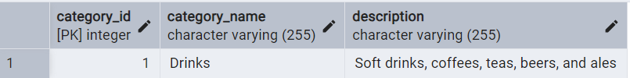

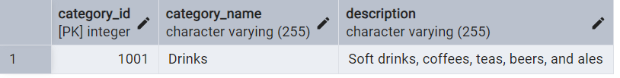

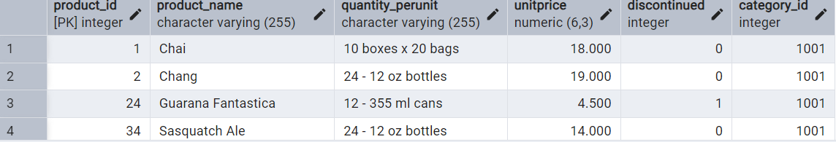

**DELETE FROM categories**

**WHERE category_id=3**

**select * from products**

**where category_id=3**

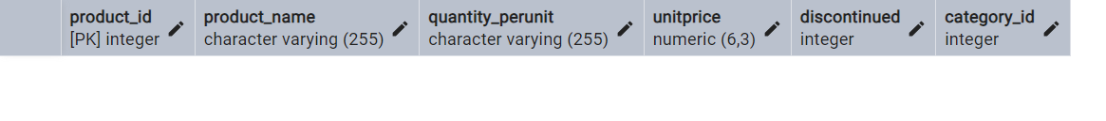

**4)      Delete the customer = “VINET”  from customers. Corresponding customers in orders table should be set to null (HINT: Alter the foreign key on orders(customerID) to use ON DELETE SET NULL)**

**ALTER TABLE orders**

**DROP CONSTRAINT IF EXISTS fk_customer**

**ALTER TABLE orders**

**ADD CONSTRAINT fk_customer**

**FOREIGN KEY (customer_id)**

**REFERENCES customers(customer_id)**

**ON UPDATE SET NULL**

**ON DELETE SET NULL**

**DELETE FROM customers**

**WHERE customer_id='VINET'**

**select * from orders**

**WHERE customer_id IS NULL**

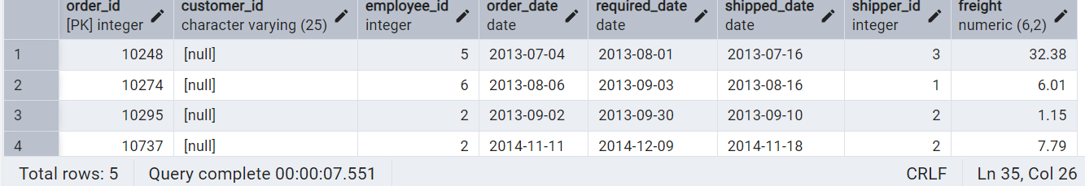

**5)      Insert the following data to Products using UPSERT:**

**product_id = 100, product_name = Wheat bread, quantityperunit=1,unitprice = 13, discontinued = 0, categoryID=5**

**product_id = 101, product_name = White bread, quantityperunit=5 boxes,unitprice = 13, discontinued = 0, categoryID=5**

**product_id = 100, product_name = Wheat bread, quantityperunit=10 boxes,unitprice = 13, discontinued = 0, categoryID=5**

**INSERT INTO products(product_id,product_name,quantity_perunit,unitprice,discontinued,category_id)**

**VALUES(100, 'Wheat bread',1,13,0,5),**

**(101, 'White bread','5 boxes',13,0,5)**

**ON CONFLICT (product_id)**

**DO UPDATE**

**SET quantity_perunit=EXCLUDED.quantity_perunit**

**INSERT INTO products(product_id,product_name,quantity_perunit,unitprice,discontinued,category_id)**

**VALUES(100, 'Wheat bread','10 boxes',13,0,5)**

**ON CONFLICT (product_id)**

**DO UPDATE**

**SET quantity_perunit=EXCLUDED.quantity_perunit**

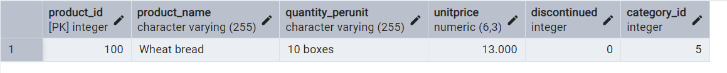

**6)      Write a MERGE query:**

**Create temp table with name:  ‘updated_products’ and insert values as below:**

|  |  |  |  |  |  |
| --- | --- | --- | --- | --- | --- |
| **productID** | **productName** | **quantityPerUnit** | **unitPrice** | **discontinued** | **categoryID** |
| **100** | **Wheat bread** | **10** | **20** | **1** | **5** |
| **101** | **White bread** | **5 boxes** | **19.99** | **0** | **5** |
| **102** | **Midnight Mango Fizz** | **24 - 12 oz bottles** | **19** | **0** | **1** |
| **103** | **Savory Fire Sauce** | **12 - 550 ml bottles** | **10** | **0** | **2** |

* **Update the price and discontinued status for from below table ‘updated_products’ only if there are matching products and updated_products .discontinued =0**

* **If there are matching products and updated_products .discontinued =1 then delete**

* **Insert any new products from updated_products that don’t exist in products only if updated_products .discontinued =0**

**MERGE INTO products p**

**using(**

**VALUES**

**(100, 'Wheat bread',10,20,1,5),**

**(101,'White bread',5,19.99,0,5),**

**(102,'Midnight Mango Fizz',24,19,0,1),**

**(103,'Savory Fire Sauce',12,10,0,2))**

**AS updated_products(product_id,product_name,quantity_perunit,unitprice,discontinued,category_id)**

**ON p.product_id=updated_products.product_id**

**WHEN matched AND updated_products .discontinued =1 then delete**

**WHEN matched AND updated_products .discontinued =0 then update**

**SET unitprice=updated_products.unitprice,**

**discontinued =updated_products.discontinued**

**WHEN NOT matched AND updated_products .discontinued =0**

**THEN**

**INSERT (product_id,product_name,quantity_perunit,unitprice,discontinued,category_id)**

**VALUES (updated_products.product_id,updated_products.product_name,updated_products.quantity_perunit,updated_products.unitprice,updated_products.discontinued,updated_products.category_id)**

* 7)      List all orders with employee full names. (Inner join)

**select * from orders o**

**inner join employees e**

**on o.employee_id=e.employee_id**

